CSA1505-Cloud computing and big data analytics
4-Patient Progress
The Patient Progress Monitoring System in Zoho Creator helps healthcare providers efficiently track and manage patient recovery and treatment updates.It enables medical staff to record patient details, update progress status, document current health conditions, and compare them with previous check-up records. The system securely stores patient information in the cloud, allowing authorized users to access and update records in real time. It also improves accuracy, reduces paperwork, facilitates faster decision-making, and generates reports for better patient care and treatment management.
INPUT
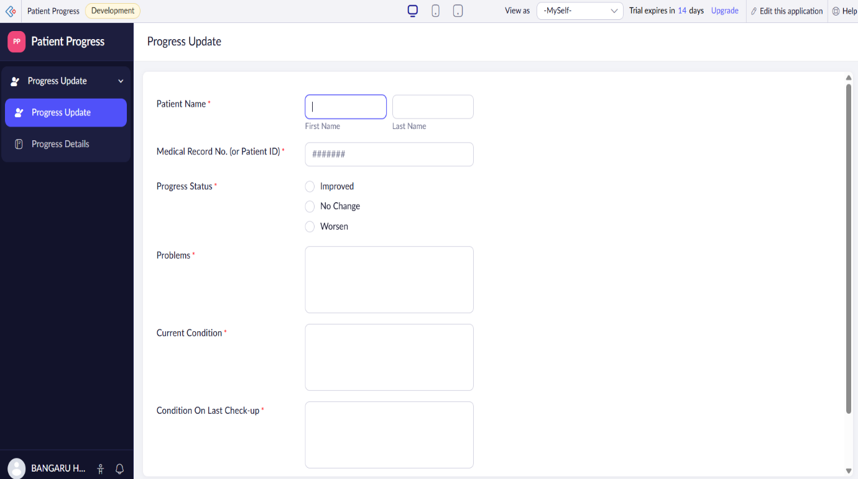

OUTPUT
